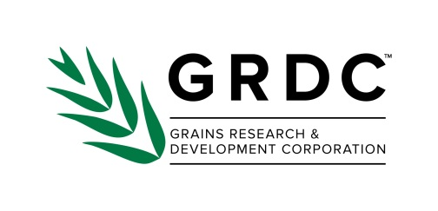

Invitation

Deeper roots: CTF machinery investment planning workshop

Workshop for farmers and consultants
Join Bindi Isbister from DAFWA, Geraldton who has extensive experience working with farmers to implement a CTF system and Wayne Parker, DAFWA to guide you through the process of developing a CTF system for your farm with short, medium and long term goals. Now is the best time to make a start.
Topics will include information on:
- soil amelioration (what to rip and what not to),
- CTF benefits & economics,
- pros & cons of different machinery widths,
- CTF case studies and,
- Using the CTF calculator to begin a machinery investment plan.
Date, time and meeting place:

18 July 2017
1:00pm – 5:00pm
Wyalkatchem Bowling Club
Type of activity: Technical workshop
Bring along your operating widths and tracks of your machinery and a laptop/IPAD (if possible) to develop your own CTF investment plan
To RSVP please contact Wayne Parker, DAFWA +61 (0)8 9956 8555 Email: wayne.parker@agric.wa.gov.au or Bernie Quade, Landmark 0427 266 880
