Looking deeper into soils: tour of soil management options

Main Tour

Day 1 (24th July): Perth to Albany
Tillage comparison on non-wetting sands – 5 years on (Brookton)
Incorporation of lime with deeper tillage on non-wetting soil (Wickepin)
Different tillage methods for ameliorating constraints (Broomehill)
Comparison of seeding machines (Tambellup)
Deep delving in deep sandy duplex (Toolbrunup)

Day 2 (25th July): Albany to Esperance
Deeper ripping comparison after claying (Kojoneerup)
Deep placement of organic matter and deep ripping on grey clay (Ongerup)
Options for non-wetting soil amelioration – 4 years on (West River)
Ripping with inclusion plates and waterlogging (Munglingup)
Stubble retention and on-row sowing (Munglingup)

Esperance Option

Day 3 (26th July): Esperance and Grass Patch Field Day
Managing multiple constraints in deep sands (EDRS)
Herbicide interactions with mouldboard plough (Esperance)
Canola trials, fungicides, lentil agronomy (Grass Patch)
Deep ripping & non-wetting soils (Grass Patch)
Nitrogen rich strips (eConnect site) (Grass Patch)
Return to Esperance

Corrigin Option

Day 3 (26th July): Esperance - Corrigin
Managing multiple constraints in deep sands (EDRS)
Herbicide interactions with mouldboard plough (Esperance)
Ripping depth and ripping tine attachments (Coomalbidgup)
Addressing multiple constraints (Lake Grace)

Day 4 (27th July): Corrigin to Perth
Society of Precision Agriculture Australia (SPAA) Tech Expo (Corrigin)
Return to Perth
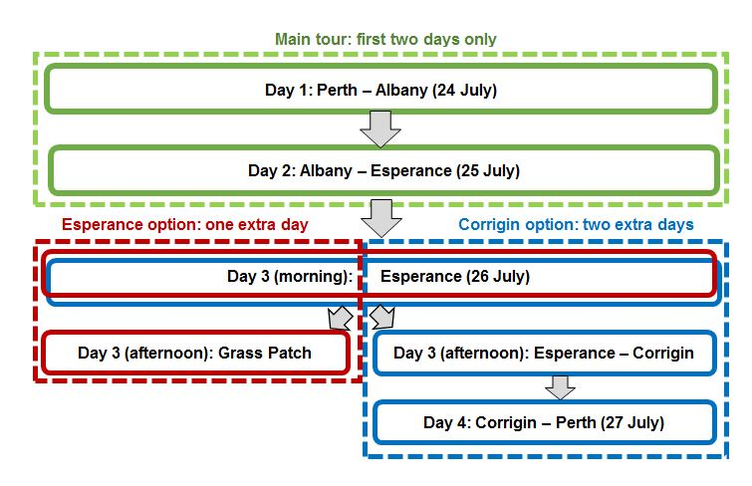
For more information or to RSVP please contact:
Glenn McDonald, Research Officer, Albany
Telephone: +61 (0)8 9892 8524
Email: glenn.mcdonald@agric.wa.gov.au

